**UNIVERSAL BASIC INCOME IN RESPONSE TO THE COST-OF-LIVING CRISIS: *The Feasibility Questions***

**Executive Summary**

* Introducing a Universal Basic Income (UBI) is desirable to the United Kingdom to aid with the cost-of-living crisis in the short run and ensures economic security (Kangas, Jauhiainen, Simanainen, & Ylikännö, 2019), lower crime rates and improved academic performance (Lacey, 2017) , and reduced poverty (Soares, Ribas , & Osório, 2010) in the long run.
* A full run UBI equates to 15% of GDP with current public expenditure on social protection being 13.7% of GDP with the difference being earned back through the economic benefits a UBI brings about through social change.
* The policy should not be run at full coverage from day one, but instead be eased in through a Cost-of-Living Commission. This commission must analyse the previous financial year and determine a suitable increase in the UBI to ultimately cover all basic costs of living, analysed to be roughly 22% of median wage.
* Data should be analysed on the financial contributions of the UBI to other social security programs to replace these and reach a balanced budget with UBI at full coverage.

**The Need for a Universal Basic Income**

The cost of living has increased rapidly in recent years as shown in Graph 1 – Cost of Living Crisis (see appendix). Market mechanisms have failed at keeping up with the increased cost of living as noted by real wages. Currently the government grants social security based on one’s inability to participate in the labour market, but do not give substantial compensation based on the recent increased living costs. Furthermore, the current social security system is somewhat dysfunctional from people falling through the cracks of not being “deservingly” poor/injured to receive grants (Phillips, 2017). Not surprisingly, 88% of Britons reported that the cost-of-living crisis is the most pressing issue facing the UK in 2024 (Office for National Statistics, 2024). With costs increasing and little support aimed at easing these costs, support for a Universal Basic Income has grown. A UBI has not been considered again since the policy was brought up in parliament as a response to the Covid-19 pandemic. As of 2023, 48% of Brits are in favour of a UBI while 28% oppose it with 24% of respondents answering “don’t know” (YouGov, 2022).

Universal Basic Income trials have been conducted in other countries with the goal of reducing poverty. These studies still apply to the UK as 21% of the population lives in relative poverty prior to the spike in cost of living seen in Graph 1. Overall, the trials saw stronger economic security (Kangas, Jauhiainen, Simanainen, & Ylikännö, 2019), reduced poverty (Lacey, 2017), and reduced crime rate and improved academic performance (Soares, Ribas , & Osório, 2010) . There is little evidence that a UBI causes unemployment. Contrary, the trial conducted in Finland showed the economic security provided by a UBI allowed for entrepreneurship (Kangas, Jauhiainen, Simanainen, & Ylikännö, 2019).

**Proposed level of UBI**

A UBI must by default be Universal – given to all, Basic; cover the cost of living, and Income; be a direct cash transfer. Giving every adult (18+) in the UK £150 per week would have a yearly cost of 343 billion pounds in 2022, which is 15% of UK GDP. The public sector expenditure on only social protection equals to 13.7% of GDP. The difference can however be expected to be earned back from reducing spending on those areas a UBI have proven to benefit, such as education, crime rates, and health. These numbers are arbitrary for now as there are no values estimated on the effects of a large-scale implementation of a UBI that are applicable to the United Kingdom and the analysis of this policy brief. However, the difference (1.3% of GDP) can be expected to be earned back.

Additionally, reallocating some of the 36.6% of GDP that is spent on social protection (HM Treasury, 2023) can allow for a faster implementation of a UBI at full coverage of the increased cost of living.

The average expenditure on essential costs (food, utilities, and housing) – excluding homeownership, is illustrated in Graph 2 (see appendix). The graph indicates essential costs are increasing relative to median income. As of 2022, 22.24% of median income (£150 weekly) is spent on these essential goods. A commission should analyse the yearly data to make projections of a suitable level of UBI for the following financial year, as is done for minimum wage through the Low Pay Commission. The goal of this commission should be to reach full coverage of the essential costs over time but initially simply assist with these costs.

**Political Feasibility**

It would not be politically feasible to achieve a UBI of 22% of median income (cost of 13.7% of GDP) considering the failed attempt during the Covid-19 pandemic. Instead, the government can implement a lower level of UBI to *assist* with the cost-of-living crisis. This also prevents pitfalls with the 1.3-point difference in the cost of a UBI versus current expenditure. Determining this level is a political question and outside the expertise of the author and contributors of this brief.

A committee should be appointed to analyse the previous economic year and advise the government of a suitable level for the UBI, similarly to the Low Pay Commission. The Cost-of-Living Commission (CLC) should have as a goal to ultimately cover the cost of living as a percentage of median income and not just assist with costs.

It is important to note that the UBI examined in this brief is ultimately a replacement to the current welfare system to avoid having individuals fall through the cracks during the cost-of-living crisis. Jaravel and Ghatak (2020) considered the expansion of the welfare state to provide a UBI in addition to current social protection can be obtained with a 45% flat tax throughout all income brackets. No analysis of such a tax level is not applicable today and should not be considered until the UBI has reached the 22% mark of median income, and the economical implications are measurable.

**Recommendations**

In the short run, the government should establish a Cost-of-Living Commission (CLC) to determine the appropriate level of a Universal Basic Income. The government should also publicly endorse reaching a level around 22% of median income. However, the first level of UBI should be expected to be much lower as it aims at *assisting* with the crisis. Legislation made around the UBI must include inflation adjustments to prevent cost-of-living crises.

In the medium run, analysis of the impact of UBI on the tax system by income groups should be conducted to plan for future restructuring. Analysis must be done on the monetary value the UBI has created in education, policing, and housing.

The long run goal of the CLC is to ensure coverage of the costs of living. Restructuring of the social security system to account for a Universal Income.

Bibliography

HM Treasury. (2023). *Public Expenditure.* London: Open Government Licence.

Institute for Economic Justice. (2021, March 16). *Institute for Economic Justice.* Retrieved April 15, 2024, from https://www.iej.org.za/introducing-a-universal-basic-income-guarantee-for-south-africa/

Kangas, O., Jauhiainen, S., Simanainen, M., & Ylikännö, M. (2019). *The basic income experiment 2017–2018 in Finland : Preliminary results.* Helsinki: Ministry of Social Affairs and Health.

Lacey, A. (2017). Universal basic income as development solution? *Global Social Policy, 17*(1), 93-97. Retrieved April 15, 2024, from https://journals.sagepub.com/doi/10.1177/1468018116684269

Mackley, A., Hobson, F., Loft, P., & Kennedy, S. (2020). *The Introduction of a Universal Basic Income.* London: House of Commons Library. Retrieved April 15, 2024, from https://commonslibrary.parliament.uk/research-briefings/cdp-2020-0096/

Office for National Statistics. (2020, March 25). *Measures of owner occupiers' housing costs, UK: October to December 2019*. Retrieved April 15, 2024, from https://www.ons.gov.uk/economy/inflationandpriceindices/articles/understandingthedifferentapproachesofmeasuringowneroccupiershousingcosts/octobertodecember2019

Office for National Statistics. (2024). *AWE: Whole Economy Year on Year Three Month Average Growth (%): Seasonally Adjusted Total Pay Excluding Arrears*. Retrieved April 15, 2024, from https://www.ons.gov.uk/employmentandlabourmarket/peopleinwork/earningsandworkinghours/timeseries/kac3/lms

Office for National Statistics. (2024). *Consumer Price Inflation, UK: January 2024*. Retrieved April 15, 2024, from https://www.ons.gov.uk/economy/inflationandpriceindices/bulletins/consumerpriceinflation/january2024

Office for National Statistics. (2024). *CPIH ANNUAL RATE 00: ALL ITEMS 2015=100*. Retrieved April 15, 2024, from https://www.ons.gov.uk/economy/inflationandpriceindices/timeseries/l55o/mm23

Office for National Statistics. (2024). *Gross Domestic Product: chained volume measures: Seasonally adjusted £m*. Retrieved April 15, 2024, from https://www.ons.gov.uk/economy/grossdomesticproductgdp/timeseries/abmi/ukea

Office for National Statistics. (2024). *Index of Private Housing Rental Prices, UK: January 2024*. Retrieved April 15, 2024, from https://www.ons.gov.uk/economy/inflationandpriceindices/bulletins/indexofprivatehousingrentalprices/latest

Office for National Statistics. (2024). *Monthly gross domestic product by gross value added*. Retrieved April 15, 2024, from https://www.ons.gov.uk/economy/grossdomesticproductgdp/datasets/monthlygrossdomesticproductbygrossvalueadded

Office for National Statistics. (2024). *Public opinions and social trends, Great Britain: 13 to 24 March 2024*. Retrieved April 15, 2024, from https://www.ons.gov.uk/peoplepopulationandcommunity/wellbeing/bulletins/publicopinionsandsocialtrendsgreatbritain/13to24march2024#:~:text=The%20following%20information%20is%20for,and%20the%20economy%20(70%25).

Phillips, T. (2017). *Falling through the cracks.* London: Resolution Foundation.

Redfield and Wilton Strategies Research Team. (2021). *Universal Basic Income Supported by a Majority of British Public*. Retrieved April 15, 2024, from https://redfieldandwiltonstrategies.com/universal-basic-income-supported-by-a-majority-of-british-public/

Soares, F., Ribas , R., & Osório, R. (2010). EVALUATING THE IMPACT OF BRAZIL'S BOLSA FAMÍLIA: Cash Transfer Programs in Comparative Perspective. *Latin American Research Review, 45*(2), 173-190. Retrieved from https://www.jstor.org/stable/27919200

YouGov. (2022). *UBI in the UK.* YouGov.

APPENDIX

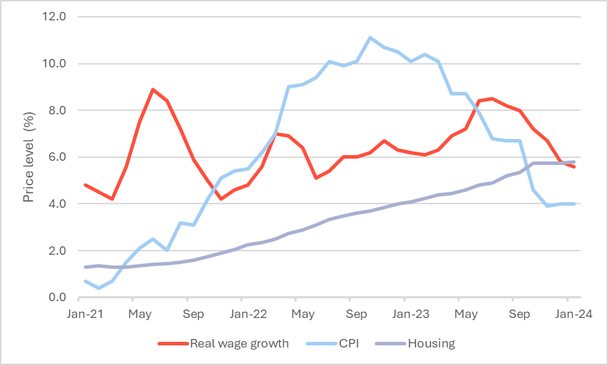

Graph 1 - Cost of Living Crisis (data retrieved from The Office of National Statistics)

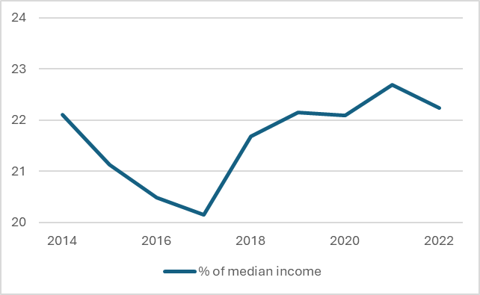

Graph 2 - Household expenditure on essential costs as a fraction of median income